Prompt：Move the three white-rimmed storage bins from Pick Station 6 to Place Station 1.

JCIIOT 2026 Operation Instruction Sheet
Electronics Factory Material Handling Task
Task Name: Material Handling Task
Task Number: SOP-ELC-001-2026-GEN
Version: 1.0
Effective Date: April 23, 2026

I. What This Task Is All About
Simply put, this task is about moving designated materials from a Pick Station to a Place Station.
While the process might seem straightforward, there are a few things to keep in mind:
- Don't pick up the wrong material.
- Don't bump into anything nearby.
- Don't drop anything halfway.
- Don't place it crookedly.
- If there are obstacles on the way, dodge them.
In short: Be steady, be accurate, and safety first!

II. Before You Start, Take a Look Around
Before officially beginning, it's a good idea to double-check things to avoid discovering issues halfway through.
1. Understand the Task Information Clearly
First, confirm these details:
- Is this the task you're supposed to be doing?
- Is the starting point the Pick Station?
- Is the end point the Place Station?
- Which specific material are you moving?
- How many do you need to move?
2. Check the Item You Need to Move
Once you're on-site, identify the target material first. Don't just grab it immediately.
Main things to check:
- Does the appearance match?
- Are the color, size, and label correct?
- Is it in the right position?
- Is anything blocking it, making it hard to pick up?
3. Quickly Check Equipment Status
Whether it's human-operated or automated equipment, it's a good idea to check if it's ready to work:
- Is the navigation system working?
- Is the gripper/fixture functional?
- Is the identification function working?
- Are there any anomalies around?
- Is the equipment in an operational state?
4. Don't Ignore the Environment
Sometimes the problem isn't the task itself, but the environment. It's recommended to check:
- Is the path clear?
- Is the starting point unobstructed?
- Is there space at the end point for placement?
- Is there any clutter on the ground?
- Are there any surrounding conditions that might affect handling?

III. Operating Steps

Step 1: Go to the Pick Station First
Move to the Pick Station.
Once there, don't rush to grab. Look around first and confirm:
- Are you at the correct location?
- Is the target material here?
- Is anything else blocking the area?
- Is there a risk of collision?
- Is the current position convenient for grasping?
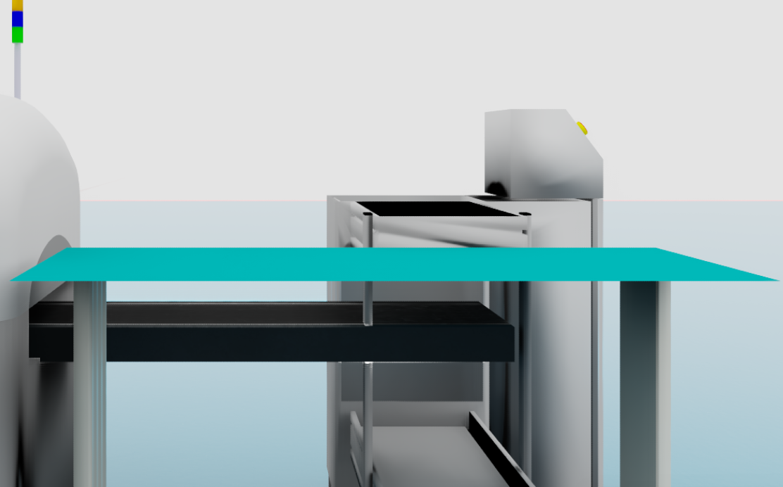
Step 2: Find the Target Material and Pick It Up
Once you're at the starting point, identify the target material.
Confirm it's the one you need to move, then prepare to grab.
When grabbing, pay attention to a few points:
- First, pinpoint the exact location.
- Check its orientation.
- Figure out the most convenient way to grab it.
- Make sure the grabbing path doesn't hit anything nearby.
- Try to make the movement smooth; don't lunge at it.
After picking it up, double-check:
- Is it held firmly?
- Is it crooked?
- Will it slip?
- Did you grab the wrong thing?
If it feels unstable, it's better to start over than to push through stubbornly.
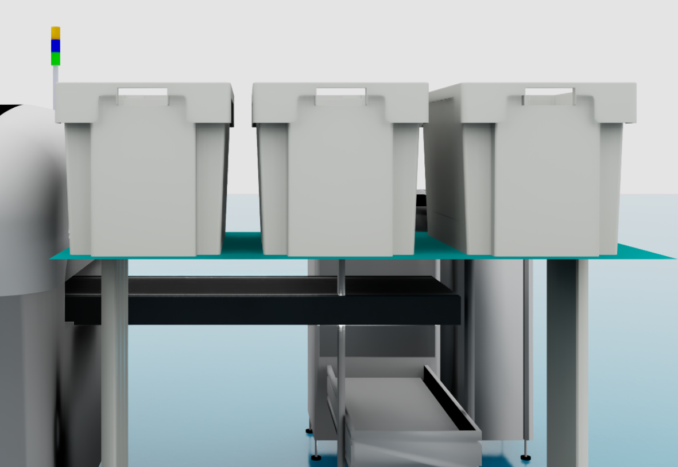
Step 3: Move from Pick Station to Place Station
Once you've got a firm grip, you can head towards the Place Station.
The key here is simply: move steadily.
On the way, pay attention to:
- Try to take a safe and smooth route.
- Don't try to squeeze into dangerous spots just to save a little distance.
- If you spot an obstacle, dodge it promptly.
- If you absolutely can't get around it, stop for a moment; don't just ram through.
- Avoid excessive shaking during transportation.
- Don't let the material hit nearby equipment or other goods.
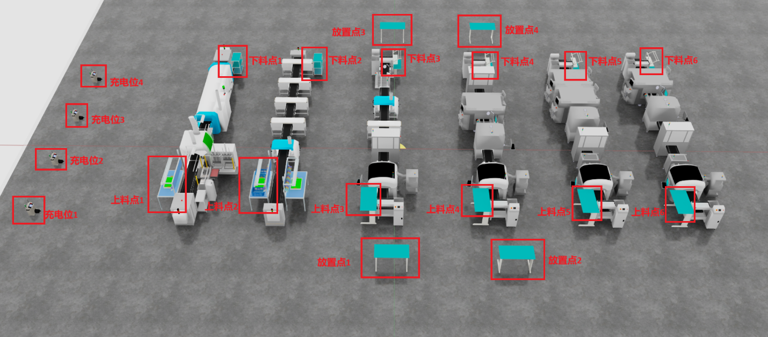
Step 4: Place the Material Properly at the Place Station
Once you arrive at the Place Station, don't just place it immediately. First, confirm the placement area.
Check:
- Is this spot empty?
- Is anything else occupying it?
- Will placing it here bump into other materials?
- Is there enough space for placement?
Only place it after confirming everything is okay:
- First, align it.
- Slowly lower it.
- Release it only after it's stable.
- After releasing, take another look to confirm it's not crooked, not toppled, and not out of bounds.

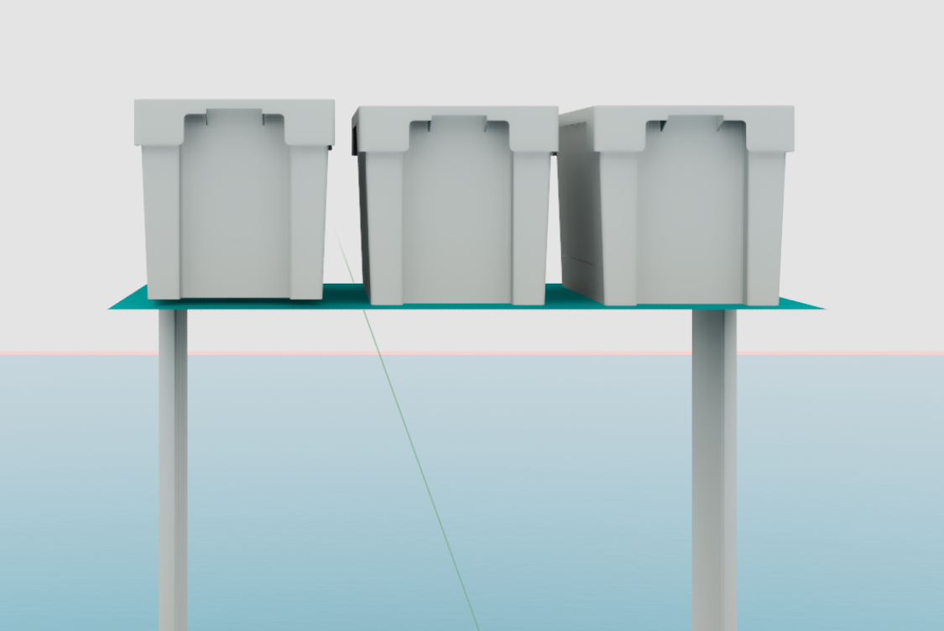
Step 5: If There's More Than One, Repeat
If the task involves moving more than one item, then repeat the previous actions:
- Return to the starting point.
- Find the material again.
- Grasp.
- Transport.
- Place.
It's best to re-confirm each time. Don't skip steps just because you're doing repetitive work.
Many problems arise from thinking "good enough is fine."

Step 6: Wrap Up
After moving everything, remember to wrap things up:
- Confirm if the correct quantity has been moved.
- Check if anything was placed in the wrong spot.
- Confirm nothing was missed.
- Return to the standby area, or prepare for the next task.
- Fill out the records.
If any anomalies occurred during the process, make a note of them for future reference.

IV. What to Do If Something Goes Wrong
On-site tasks can't always go perfectly smoothly; things happening is normal. The key is not to panic.
1. If You Bump Into Something
If you accidentally bump into something while moving or operating:
- Stop immediately.
- Check what was hit.
- Inspect the material, equipment, and surrounding situation.
- If you can go around, re-plan the route.
- If you can't handle it, report the anomaly quickly.
2. Material Drops
If the material drops while being moved:
- Stop immediately.
- Assess the material's condition and the surrounding environment.
- If it can be safely re-grasped, do so.
- If it cannot be safely handled, report the anomaly first; don't force it.
3. Path Is Blocked
If there's suddenly an obstacle on the path:
- Slow down or stop.
- See if you can find an alternative route.
- If you can go around, do so.
- If you can't go around, wait or report the anomaly.
4. SOP Doesn't Match On-Site Reality
If you find that what's written in the SOP is completely different from the actual situation on-site:
- Don't continue.
- Stop and confirm.
- Report to the person in charge.
- Wait for clarification before proceeding.
In short: When in doubt, don't just power through.

V. Important Notes
Safety Aspects
- Safety first, efficiency second.
- If something feels wrong, stop first.
- Don't let materials drop.
- Don't hit people, equipment, or goods.
- Don't continue moving if it's unstable.
Quality Aspects
- Identify the target material correctly.
- Grasping must be steady.
- Placement must be accurate.
- Don't place it crookedly, off-center, or out of bounds.
- It's best to double-check after moving is complete.

